Balloons Over Wadsworth
Hot Air Balloon Event
Emergency Action Plan
August 8th- 10th, 2025, Wadsworth Municipal Airport,
Wadsworth Ohio


Table of Contents
 | Part I-Basic Plan
Page # | Title
3 | Introduction & Emergency Services Briefings
4 | Emergency Procedures for Staff & Law Enforcement
6 | Mass Casualty Plan
6 | Mass Evacuation – Severe Weather / Tornado Warning
7 | Vape Sniffing Dog Option & Active Shooter Guidelines
7 | Transfer of Command Policy
9 | Schedule of Events
10 | Reason & Purpose for Guide
10 | Hazard Vulnerability Analysis
 | Part II- Emergency Procedures Checklist
Page # | Title
11 | Unified Command
12 | Fire & Rescue Officer-in-Charge
13 | Law Enforcement Officer-in-Charge
14 | Access Control Points & Traffic Control Points
15 | Emergency Medical Services Officer-in-Charge
16 | Communications & Warning Officer
17 | Public Information Officer
19 | Public Announcement Officer
 | Part III- Attachments
Page # | Title
20 | Hazardous Material Information: Propane
20 | Emergency Contacts
21 | Event Ground Map
22 | Incident Management Form: Action Log
23 | Incident Management Form: Security Sign In/Out Log
24 | Incident Management Form: Resource Request Status Log
25 | Pilot Roster

Introduction
The “Balloons Over Wadsworth” (B.O.W) Hot Air Balloon Event brings in hot air balloon pilots, enthusiasts, as well as spectators, from across the State of Ohio as well as adjoining States. The main attractions for the Balloon event are the 24 balloons, which lift off in the early morning and early evening, and the Night Glow on Saturday evening of August 9th. This plan has been developed to address the special concerns that the balloons may present, as well as provide for the welfare of the participants and spectators of this event utilizing the National Incident Management System.
It also addresses overall crowd control & emergency procedures of ALL festival related activities within both the Hot Air Balloon and Festival events all weekend long. All activities originate on contiguous and shared space under the control of Inspire Aviation and Wadsworth Municipal Airport.

The Goal of Emergency Services
- Provide the public, pilots and participants the highest level of safety and emergency response possible.
- Provide the highest level of fire protection possible.
- Provide spectators a high level of emergency first aid and/or medical attention and transport to a higher level of care as needed.
- Provide appropriate Command/Control of an incident or accident.
- Well communicated emergency evacuation procedures.

EMERGENCY SERVICES BRIEFINGS
1. Safety Personnel Meeting and Overall Emergency Services Briefing Prior to the event letter, will be mailed or delivered to all emergency service entities by Chris Smart, Event Director. This is to inform them of the event and goal of the organizers to be ready for possible emergencies, advise them of the races, familiarize personnel with the field layout, and identify final logistical needs for emergency services. Opportunity for them to adjust schedules for personnel and advise the Event Organizers of any special restrictions they may have. Drafts of this Emergency Action plan will be delivered to all appropriate agencies in July (in draft form) and again 7 days prior to the event (in final form).

2. Pilots Daily Briefing
Each morning the Balloon Meister with his Safety Officer and Weather Officer along with the
Local Event Director & their designees is responsible for conducting a pilot pre-flight briefing (see Operations Manual for further details), pilot roll call will be taken. Pilots will sign-in to briefing as well.

3. End of Event “Wrap Up” Briefing – (Sunday after the conclusion of the Awards Banquet)
This briefing will include the Balloon Meister, Competition Director, Safety Officer and Weather
Officer along with local Event Director as well as a representative from propane/refueling area if applicable to address the issues encountered over the event period to improve safety for the next year’s event.

Emergency Procedures for Staff & Law Enforcement
Pilot notification: Messages regarding the “go” or “no go” status of scheduled launches will be disseminated to the pilots via their personal mobile phones. Also, emergency messages, such as “land ASAP”, will be disseminated via the mobile phones. This will be done with group texting functions in concert with the Balloon Meister and Weather Officer.

Spotters
All members of the Balloons Over Wadsworth Committee, as well as Pilot Ground Crew, will act as spotters during the event. Any safety concern will be reported directly to the Safety Officer or the Balloon Meister.
Notification of an off-site accident: The Balloon Meister and the Event Director (Chris Smart) as well as the Safety officer (Sean Askren) should be notified along with Medina County 9-1-1. In the event of a balloon accident, the emergency response team should tend to the injured, but the equipment, by law, should not be disturbed in any way. It must remain in place until inspected by either Federal Aviation Administration (FAA) or National Transportation Safety Board (NTSB) representatives before it is moved.

Law Enforcement Response to Aircraft Emergencies On-Site Accidents: Responders shall comply with instructions from the on scene ESD/IC to protect the scene of an incident until proper authorities are on-site. If local law enforcement agencies are on scene, they will be primary control of law enforcement. In the event of a serious on-site aircraft emergency / mishap within the Launch Field or other controlled area, the following law enforcement response will occur:
1. The first law enforcement officer on the scene will assume control of the law enforcement response and will coordinate the support of all BOW Balloon Committee volunteers as needed. 2. The Law Enforcement Branch Director will consult with the IC regarding the need for offsite resources and will make the request directly to dispatch.
- BOW Staff will help prevent spectators, crews, and other non-essential personnel from responding to the aircraft emergency/mishap site when available.
- Ingress traffic will be strictly monitored to ensure that only essential personnel are permitted access to the aircraft emergency/mishap site.
- On-scene law enforcement officers will make every attempt to aid crew members, families and friends of an aircraft emergency/mishap victim as the situation warrants.
- No law enforcement or security officer shall respond to an aircraft emergency/mishap site unless specifically directed by the IC.
- Notification to FAA/IIC - Further notification of the FAA IIC will be made as expeditiously as possible.

Off-Site or Accidents Outside of the Controlled Areas
Emergency response of law enforcement personnel and Asst. Safety Officer will respond to an off-site accident for support when directed by the IC (Incident Commander). Notification of the FAA/IIC will be in accordance with line #7 above.

No Communications with Media in the Event of an Emergency:
In the event of any accident or crisis during this event, No Pilot, Crew Chief, Crew or event staff or volunteer are to make statements to the public or the media. This is the job only of the Public Information Officer, Tom Strong, or the Unified Command.

EMERGENCY ROLE OF BALLOONS OVER WADSWORTH BALLOON
STAFF:
In the event of an accident resulting in serious injury or death to any pilot or balloon festival participant the staff will report immediately to the Airport Terminal building – Main Classroom when they have finished any Life Safety activity. In the event of a mass casualty incident, the Staff will respond to the Incident Commander (Chris Smart – also the Event Director) and direct BOW resources, pilots, and crews to assist with the incident and give reliable reports and updates to the Incident Commander. Any BOW Executive Staff member may be assigned the Public Information Officer (PIO) role at the Incident Commander’s (IC) discretion. Terminal Building (1st Emergency Command Post) will act as the debriefs of staff and scheduled briefings.

CROWD CONTROL-Launch Fields
Crowd control will be the responsibility of the Safety Officer & Asst. Safety Officer assisted by BOW staff and volunteers in the launch field. All crowd control volunteers and officials will be wearing BOW STAFF Shirts for easy identification. The PA system will be used to update the crowd in any emergency and given instructions for safe evacuation.

CROWD CONTROL-Target areas
Spectators will not be allowed within the confines of the fence for Wadsworth Municipal Airport targets on morning flights. Balloon crews will be allowed to enter up to 200 feet of the target area. If requested by the pilot the chase crew will be allowed to enter the 200-foot perimeter of the target, but the pilot score will be zero. The scoring and measuring officials will be responsible for crowd control, if needed, within 200 feet of the target area and will maintain the 1000-foot perimeter of any off-site targets. Score keepers and volunteers will manage spectators at off-site targets and advise of emergency situations.

MASS CASUALTY INCIDENT PLAN
A Mass Casualty Plan has been adopted by Medina County & Wadsworth Police Department and is the responsibility of the City Manager & Chief of Police of Wadsworth. At any time that a requirement for such a response is equal to or exceeds the resources available to meet its needs, mutual aid agreements will be enforced, and outside agencies will be requested. While this definition does not imply multiple casualties even a “minor” incident can be classified as a “mass casualty” if adequate resources are not available to properly respond. All balloon events have the potential for a multi-casualty incident. The Medina County Unified Command Team are organized to very quickly and effectively handle a multi-casualty incident by the pre-positioning of resources and being organized to directly follow the established Medina County Emergency Plan (County Plan). In the event of a multi-casualty incident at the command structure and emergency resources are already in place to immediately start managing the incident. The IC will be the first person to respond to the incident of Fire, EMS, and Law enforcement. Additional Fire, EMS, and Law Enforcement resources may be requested as needed through a normal process with all parties involved notified and a specific time given. Many systems, procedures and safety features are in place to prevent a multi-casualty incident at the Balloons Over Wadsworth Festival. However, if an unfortunate incident occurs, there is a plan for trained personnel and resources to effectively handle it.

MASS CASUALTY EVACUATIONS
The Medina County Emergency Mass Casualty Evacuation Plan will utilize Wall Rd access to the South End of the Airport to access the entire festival site to enter and exit for local hospitals. This provides the best rapid response routes unless otherwise determined by circumstances of the incident. Such evacuation routes would then be determined by medical and/or law enforcement agencies involved. Other evacuation options could utilize, depending upon severity of medical conditions, helicopter airlift. Important to note the Cleveland Clinic Medivac is based out of Wadsworth Municipal Airport, so there is already reallocated helicopter operations area at the airport.

MASS CASUALTY – SPECTATOR/CROWD EVACUATION
Crowd evacuations in the event of an on-balloon-field mass casualty incident would be determined based upon the circumstances using the safest routes available. Such routes would include all the vehicle and/or pedestrian walking paths into or out of the airport. Pedestrians have virtually all 360 degrees of egress to leave the field / festival area. All non-essential response personnel and event volunteers will be utilized to provide direction, guidance and assistance to evacuees if necessary. Traffic control will be provided for the parking area and anyone that parked on airport grounds. Additional assistance will be provided through verbal announcements from the event announcer’s stage located next to the launch field on a routine basis.

MASS EVACUATIONS - TORNADO WARNING:

Every effort will be made to begin evacuation processes early in the event of both Severe
Thunderstorms and any potential Tornado situation. Crowd evacuations in the event of a
Tornado Warning of all Balloon Based events would be enacted by the Hot Air Balloon Event Directors. Analysis of potential weather conditions that could cause even a “tornado watch” would cause any potential Balloon activity to be cancelled due to high winds. There are eight tornado warning sirens located in the City of Wadsworth, with one being less than one mile away from the airport. That along with the Weather Officer monitoring conditions would cause Event Directors & Staff to begin evacuation. All significant events have sound systems. All announcers will pull the best emergency directions for buildings to approach for immediate safety. All nonessential response personnel and event volunteers will be utilized to provide direction, guidance and assistance to evacuees if necessary. In the event of a pending tornado, traffic control will discourage guests from entering their cars and assist immediate evacuation to the closest indoor locations.
Active Shooter Awareness / Procedures:
Priority in an active shooter situation would be to get individuals to safety in a safe, quick manner. It is natural to run / escape by going the opposite direction of any gunshot sounds. When any staff on walkie talkies would hear or witness an active shooter they should announce “ACTIVE SHOOTER” with their location(s) and direction of movement. Then all staff should guide and support the public in going in the opposite direction of the danger.
Run-Hide-Fight is a good plan to follow.
RUN- run to safety. Keep in mind if you are exiting a building you want to scan the outside perimeter before running out to avoid attack by a possible second shooter. Help others get to safety ONLY if it is safe for you to do so and does not prolong your escape.
HIDE- if you cannot escape safely, find a suitable hiding area. This room should consist of solid doors, no windows or minimal windows, a secure door (a door that can be locked). Turn of all lights, turn off the volume on your phone and the vibrate. Keep calm.
FIGHT- if the shooters access your hiding place, be prepared to fight. Use anything you can lift to defend yourself. For example: fire extinguisher, tables, chairs, even pens. Be vigilant and watch for unusual or strange behavior in an individual. Look for baggy clothing with full pockets or a person wearing a long trench. (Long trench coat in the middle of summer). In the event of an active situation call 9-1-1. Police will clear the area. Listen to all commands that police give you.
VAPOR Dog in event of concern:
Law enforcement agencies have had to find effective ways to defend the public from growing terrorist threats. Vapor Dogs, a class of K-9s trained to detect and deter suicide bombers. They are considered the gold standard for public safety. Vapor dogs are trained to sample the air for human heat “plumes” that may contain explosive particles. When a person begins moving, that plume trails behind, like how a boat or flock of geese may leave a wake pattern in the water. The dogs can detect explosives in large, moving crowds and in distracting environments like airports, concert venues, and theme parks. Vapor dogs are trained to detect a suicide bomber in a crowd of moving people. Vapor Dogs attend a rigorous training process.
Ohio State Police (OSP) MAY BE CALLED IN if any concern arises. We may call 911 with any concerns. They WILL NOT be on site unless called with an emergency

TRANSFER/PASS OF COMMAND
Command of an incident is transferred to improve the quality of the Command organization. The probability of an exchange of command is likely to occur. The fact that a “higher ranking” person may have arrived on the scene does not necessarily mean that he/she is prepared to assume Command of the incident as they may not have adequate knowledge of the situation or how to execute the provisions of the Emergency Response Plan. The preferred method of transferring Command is through a face-to-face meeting between the initial IC and the subsequent IC. During such an exchange it is critical that a comprehensive briefing take place. Such a briefing should include, at a minimum, the following information:

- Present incident status/conditions (rescue situations, injuries, hazards, etc.)
- The strategies and tactics being employed.
- Progress toward achieving incident objectives.
- Safety considerations and concerns and conduct personnel accountability roll call.
- Assignment/deployment of resources being used.
- Projection of incident conditions i.e., escalating or diminishing and resource needs and availability.
It is generally recommended, to preserve continuity that changes in Command be held to a minimum, and therefore should be passed only one time, and only if deemed beneficial and necessary, and then only under extraordinary circumstances to protect the integrity of the incident.

MEDIA INFORMATION
All requests for information, interviews, and media footage shall be referred to and/or must be approved by the Balloons Over Wadsworth Event Director (Chris Smart) or Unified Command. All Emergency Service personnel shall refrain from any contact with the media. If asked for comments, please refer the media to the Balloons Over Wadsworth- Balloon Festival Event Director (Chris Smart). In the case of an accident/crash, absolutely no comments/ interviews shall be given by Emergency Personnel or Festival Staff or Volunteers to the media. All accident/crash information releases shall be handled by the Balloons Over Wadsworth Festival Committee or Unified Command.

2025 Balloons Over Wadsworth
Tentative Pilot Schedule - (As of 4/22/25)
Friday, August 8th

0600 Preparation for Media Flight
0630 Sunrise
0630-0730 Media Flight launch period
0830 Refueling start time
1430-1630 Balloonist Check-in Master Briefing at Check-In room 1630
1700-1830 Pilots & VIP Dinner
1830-1900 Flight Briefing
1900-1930 Balloon Launch period-Sponsor Flight
2030 Propane Refueling
2034 Sunset

Saturday, August 9th

0530 Master Briefing Hotel
0600-0900 Airport Closure
0631 Sunrise
0631-0730 Launch period for Competition flight
0830 Propane Refueling
1600 Balloons Return
1615-1715 Pilot Autograph Session
1730-1830 Balloon Meal Sponsor Dinner
Helicopter rides TBD
1830-2033 Tethered Balloon Rides
1830 Pilot Briefing in Tent
1900-1930 Balloon Launch Period
Balloons Return to Glow
2030-2130 Balloon Glow/Fuel Immediately Following
2033 Sunset

Sunday, August 10th

0530 Pilot Briefing Hotel 0632 Sunrise
0632-0730 Launch Period for Competition Flight
0830 Fueling Begins
10:30 Awards Brunch at Hotel

Reason for Plan
An emergency action plan is needed to ensure the protection of the public and event personnel and the interest of the sponsors of the “Balloons Over Wadsworth” Hot Air Balloon Event located in Wadsworth, Ohio.

Purpose of Plan
Medina County has many capabilities and resources, which would be used in response to the “Balloons Over Wadsworth” balloon event, in the event of an emergency or disaster. The purpose of this plan is to ensure the effective, coordinated use of these resources, to maximize the protection of life and property during the Wadsworth Balloon Event.

Hazard Vulnerability Analysis
Types of Hazards |  |  | Probability |  | Impact
 |  | High | Medium | Low | High | Low
Balloon Crash |  |  |  | x | x
Fire, Large Structure |  |  |  | x |  | x
Airplane Crash |  |  |  | x | x
Chemical Spill |  |  |  | x |  | x
Gas Line Break, Major |  |  |  | x |  | x
Hailstorm, Severe |  |  | x |  | x
Thunderstorm, Severe |  | x |  |  | x
Tornado |  |  |  | x | x
Transportation Accident |  |  | x |  |  | x
Other: Wind (High, Damaging) |  |  | x |  | x

Problem | How to Evaluate | Emergency Action | Required  Equipment,  Material,  Personnel | Notification | Data
Balloon  Incident: Tend to the injured, but the equipment, by law, should not be disturbed in any way. | View Incident Site.  What is involved? | Stop event if necessary Secure area.  Notify emergency response agencies.  Activate site plan Activate MCI plan if needed. | Event  Director,  Balloon  Meister,  EMS, Fire, Police, & Resources.  Implement  Command  Post. | On Site:  Balloon Meister  Event Director  Event Announcer  Communications  Coordinator  Off Site:  Medina County  9-1-1, FAA | # injured  Transport, equipment Damaged.  Keep event log.

Unified Command
Responsible for: Overall event and emergency incidents
Reports to: Emergency Personnel, FAA, Other
Primary Personnel: Chris Smart, Balloon Event Director, Pilot – Chris Smart, Balloonmeister,
Wadsworth Fire Chief, Wadsworth Police Chief, Medina County Sheriff
Mike Bowser, Inspire Aviation Director
Assisting Agencies: Fire & Rescue, Law Enforcement, & EMS agencies, county, region, & state agencies
Date of Activation: ___________ Reason for Activation: ______________________
 | Completed or N/A |  | By  (Initials) |  | Time |  | Item
 |  |  |  |  |  |  | Materials & Information Inventory
 |  |  |  |  |  |  | Copy of the Emergency Guide
 |  |  |  |  |  |  | Notification & Resource Manual
 |  |  |  |  |  |  | Radios & Cell Phones
 |  |  |  |  |  |  | Reviewed Checklist
 |  |  |  |  |  |  | Notified of an emergency by 9-1-1 Center or emergency response agencies
 |  |  |  |  |  |  | Open & maintain Unified Command Action Log
 |  |  |  |  |  |  | Verify radio frequencies & establish communications
 |  |  |  |  |  |  | Establish Public Address System & ensure that it is operational
 |  |  |  |  |  |  | Operations
Coordinate the operation of each aspect of the B.O.W. event, including
Balloon Pilots, Parking, Restrooms, Sanitation Removal, & Concession Stand
 |  |  |  |  |  | Coordinate all aspects of emergency response to & recovery efforts from an emergency on the grounds of the “Balloons Over Wadsworth” event
 |  |  |  |  |  | Request additional resources if needed through 9-1-1
 |  |  |  |  |  | Assess situation and provide update to 9-1-1/EMA
 |  |  |  |  |  | Advise Balloonists & Public of event status & any emergency precautions
 |  |  |  |  |  | Assign a Staging Officer to maintain Staging Area
 |  |  |  |  |  | Assign & delegate any other operation that is needed to address the incident
 |  |  |  |  |  | Protective Actions
 |  |  |  |  |  | Make recommendations to evacuate or to shelter the population as needed. Secure site in the event of a balloon accident.
 |  |  |  |  |  | Keep 9-1-1/EMA informed of the incident status

Fire & Rescue Officer-in-Charge
Responsible for: Firefighting/Rescue & HazMat Response Reports to: Unified Command
Primary Agencies: Wadsworth Fire Department
Assisting Agencies: Local Fire Agencies
Date of Activation: ___________ Reason for Activation: ______________________
 | Completed or N/A |  | By  (Initials) |  | Time |  | Item
 |  |  |  |  |  |  | Materials & Information Inventory
 |  |  |  |  |  |  | Copy of the Emergency Guide
 |  |  |  |  |  |  | Notification & Resource Manual
 |  |  |  |  |  |  | Radios & Cell Phones
 |  |  |  |  |  |  | Notification
 |  |  |  |  |  |  | Reviewed Checklist
 |  |  |  |  |  |  | Notified of an emergency by 9-1-1 Center, B.OW. Event Coordinator, or Patron
 |  |  |  |  |  |  | Open & maintain Fire & Rescue Action Log
 |  |  |  |  |  |  | Advise Incident Commander of any unmet needs in Fire & Rescue operations
 |  |  |  |  |  |  | Coordinate all aspects of emergency fire & rescue response to & recovery efforts from an emergency on
 |  |  |  |  |  |  | the grounds of the Wadsworth Balloon Event
 |  |  |  |  |  | Coordinate the dispatch of fire & rescue resources to assist with search & rescue as appropriate/required
 |  |  |  |  |  | Coordinate fire suppression & rescue operations
 |  |  |  |  |  | Monitor & be aware of the refueling operations in all parking lots of the Wadsworth Municipal Airport.
 |  |  |  |  |  | Ensure that there is NO smoking in the refueling areas
 |  |  |  |  |  | Protective Actions
 |  |  |  |  |  | Make recommendations to evacuate or to shelter the population as needed
 |  |  |  |  |  | Make recommendations regarding the need for additional Fire & Rescue resources
 |  |  |  |  |  | Keep Incident Commander informed of the incident status

Law Enforcement Officer-in-Charge
Responsible for: Scene Security, Traffic Control, & Access/Traffic Control Points Reports to: Unified Command
Primary Agencies: Wadsworth Police Department
Assisting Agencies: Local and State Law Enforcement Agencies (Medina County Sheriff & Ohio State Police)
Date of Activation: ___________ Reason for Activation: ______________________
Completed or  N/A | By  (Initials) | Time | Item
Completed or  N/A | By  (Initials) | Time | Materials & Information Inventory
 |  |  | Copy of the Emergency Guide
 |  |  | Notification & Resource Manual
 |  |  | Radio & Cell Phones
 |  |  | Notifications
 |  |  | Reviewed Checklist
 |  |  | Notified of an emergency by 9-1-1 Center, BOW Coordinator – Chris Smart
 |  |  | Advise Unified Command of any unmet needs in Law Enforcement operations
 |  |  | Operations
 |  |  | The Wadsworth Police Department will respond to the grounds of the Wadsworth Municipal Airport provide scene security, traffic / evacuation assistance & criminal investigation if necessary. The Wadsworth Auxiliary Police & Wadsworth Police Department will be responsible for traffic control
If an emergency on the grounds of the
“Balloons Over Wadsworth” event requires an emergency mutual aid response, then the Wadsworth Police Department will provide secured emergency access & egress routes to the grounds from.
 |  |  | Protective
 |  |  | Make recommendations to evacuate or to shelter the population as needed.
 |  |  | Make recommendations regarding the need for additional Law Enforcement resources.
 |  |  | Keep Unified Command informed of the incident status.

Access Control Points (ACP)
Post  Number | Location | Responsible Agency | # of Officers (If Staffing Permits)
1 | Main Airport Entrance Weber Dr. @ Airport Dr. | N/A | 0
2 | South End of the Runway @ Wall Rd. | N/A | 0
3 | North End of the Runway @ Wadsworth Rd. | N/A | 0
Important note, posts two and three are auxiliary roads and may only be utilized in case of emergencies or excess traffic build up.

Traffic Control Points (TCP)
Post Number | Location | Responsible Agency | # of Officers
1 | Round a ‘bout @Wadsworth Rd and Seville Rd | Wadsworth Police | 2
2 | Main Airport Entrance Weber Dr. @ Airport Dr. | Wadsworth Police | 2
Personnel staffing ACP/TCP & Parking Attendants should have the following:
1. Reflective Vests 2. Lighted Batons
3. Radio Communications with: Chris Smart and necessary Event Staff.

Emergency Medical Services Officer-in-Charge
Responsible for: Basic & Advanced Emergency Medical Services Reports to: Unified Command
Primary Agency: Wadsworth Fire & Rescue
Assisting Agencies: Other Local Emergency Services
Date of Activation: ___________ Reason for Activation: ______________________
Competed or N/A | By  (Initials) | Time | Item
Competed or N/A | By  (Initials) | Time | Materials & Information Inventory
 |  |  | Copy of the Emergency Guide
 |  |  | Notification & Resource Manual
 |  |  | Radios & Cell Phones
 |  |  | Notifications
 |  |  | Reviewed Checklist
 |  |  | Notified of an emergency by 9-1-1 Center, B.O.W. Coordinator, or Patron.
 |  |  | Advise Unified Command of any unmet needs in Emergency Medical Services operations
 |  |  | Operations
 |  |  | Ambulances will be in town/ on call each day
 |  |  | During launches
Injured/sick patients will be transported to Medina
Area Hospitals (Summa Health Wadsworth Hospital)
 |  |  | If the number of patients exceeds its capacity, then Summa Health Wadsworth Hospital will activate their disaster plan.
 |  |  | EMS personnel will use the Trauma, Triage, & Transfer Protocol when evaluating the need for air medical resources
 |  |  | Emergency Mortuary Operations will be carried out per the Medina County Emergency Operations Plan
 |  |  | Monitor weather & provide for patron’s medical needs
 |  |  | Advise Unified Command if air medical resources are needed & coordinate landing zone (Cleveland Clinic Medivac is based at Wadsworth Airport)
 |  |  | Protective Actions
 |  |  | Make recommendations regarding the need for additional EMS resources
 |  |  | Keep Unified Command / Incident Commander informed of the incident status

Communications & Warning Officer Weather Officer

Steve Mitchell /Andrew Peston asst.
Responsible for: Monitoring weather & coordinating Flight Go / No-Go with Balloon Meister.
Reports to: Unified Command
Primary Agency: Medina County 9-1-1
Date of Activation: ___________ Reason for Activation: ______________________
Competed or N/A | By  (Initials) | Time | Item
Competed or N/A | By  (Initials) | Time | Materials & Information Inventory
 |  |  | Copy of the Emergency Guide
 |  |  | Notification & Resource Manual
 |  |  | Radios & Cell Phones
 |  |  | Notifications
 |  |  | Reviewed Checklist
 |  |  | Notified of an emergency by 9-1-1 Center, B.O.W. Coordinator, or Patron.
 |  |  | Operations
 |  |  | Alert the Event Director on the grounds of all-weather watches & warnings issued for the county, as well as any other situations which may have an impact on the grounds of the “Balloons Over Wadsworth” event.
The tactical frequency for all emergency & event personnel will all conform with the Medina County Emergency Plan procedures.
The following frequencies will be available:
Fire: Wadsworth Fire & Fire Central
Law Enforcement: Police Central
EMS: Medina County Central Dispatch
Government: Medina County Central Dispatch
 |  |  | Emergency Mortuary Operations will be carried out per the Medina County Emergency Operations Plan
 |  |  | Protective Actions
 |  |  | Make recommendations regarding the need for additional EMS resources
 |  |  | Keep Incident Commander informed of the incident status

Public Information Officer (PIO) – Tom Strong
Responsible for: Providing public information to the media (Tom Strong)
Reports to: Unified Command
Primary Agency: Balloon event
Inn Date of Activation: ___________ Reason for Activation: ______________________
Completed or  N/A | By  (Initials) | Time | Item
Completed or  N/A | By  (Initials) | Time | Materials & Information Inventory
 |  |  | Copy of the Emergency Guide.
 |  |  | Notification & Resource Manual.
 |  |  | Radio & Cell Phones.
 |  |  | Notifications
 |  |  | Reviewed Checklist.
 |  |  | Notified of an emergency by 9-1-1 Center, BOW Coordinator – Chris Smart
 |  |  | Operations
 |  |  | The PIO will report to the Command Post if it is activated in the Airport Terminal Building.
The only authorized officials to serve as PIO’s
(Public Information Officers) will be: (All Cell
#’s) Chris Smart, Event Director 260-224-0251
Tom Strong, BOW Chair/POI 330-464-5665
Mike Bowser, Inspire Aviation 330-807-4065
James Mitchell asst Director 269-579-0686
These individuals will have all necessary information to carry out their role as PIO.
 |  |  | The PIO's are responsible for disseminating information and instructions to the public on a timely basis and for coordinating all releases during emergency and post emergency conditions. The PIO's are responsible for reviewing and approving all information released before it is disseminated to the public.
 |  |  | Information released to the public will be gathered in cooperation with the “Balloons Over Wadsworth” event committee, Police, Fire, Ambulance, and hospital personnel as well as governmental agencies. If it becomes necessary to establish a media briefing area, the PIO's will use the Wadsworth Airport Terminal Building-Main Classroom, 840 Airport Dr. All media personnel will be asked to report to this area. In the event of a protracted emergency, news releases will be issued on a regular basis.
 |  |  | Protective
 |  |  | News Media would meet in the Main Classroom, inside the Airport Terminal Building.

Public Announcement Officer – Tom Strong
Responsible for: Public announcements & communication to the pilots
Reports to: Unified Command
Primary Personnel: BOW Balloon Meister and Event Director (Chris Smart)
Assisting Agencies: Medina County Unified Command
Date of Activation: ___________ Reason for Activation: ______________________
Completed  or N/A | By  (Initials) | Time | Item
Completed  or N/A | By  (Initials) | Time | Materials & Information Inventory
 |  |  | Copy of the Emergency Guide.
 |  |  | Notification & Resource Manual.
 |  |  | Radio & Cell Phones.
 |  |  | Notifications
 |  |  | Reviewed Checklist.
 |  |  | Notified of an emergency by 9-1-1 Center, BOW Coordinator – Chris Smart 260-224-0251
 |  |  | Operations
 |  |  | The Balloon Meister and/or Event Director will report to the Command Post if it is activated.
 |  |  | The PIO's are responsible for disseminating information and instructions to the public on a timely basis and for coordinating all releases during emergency and post emergency conditions. The PIO's are responsible for reviewing and approving all information released before it is disseminated to the public.
 |  |  | The Public Announcement Officer has the primary responsibility of advising spectators of a balloon emergency. This will be done via the public address (PA) system. The announcer is responsible for directing the spectators to a pre-designated safe area. In the event of a balloon emergency, the Balloon Meister will contact the FAA at 800-548-4094.
 |  |  | The “Balloons Over Wadsworth” Event Coordinator will communicate with Medina County 9-1-1 until Command Leadership is onsite.
 |  |  | Protective
 |  |  | Advise public of weather emergencies & directions during the events
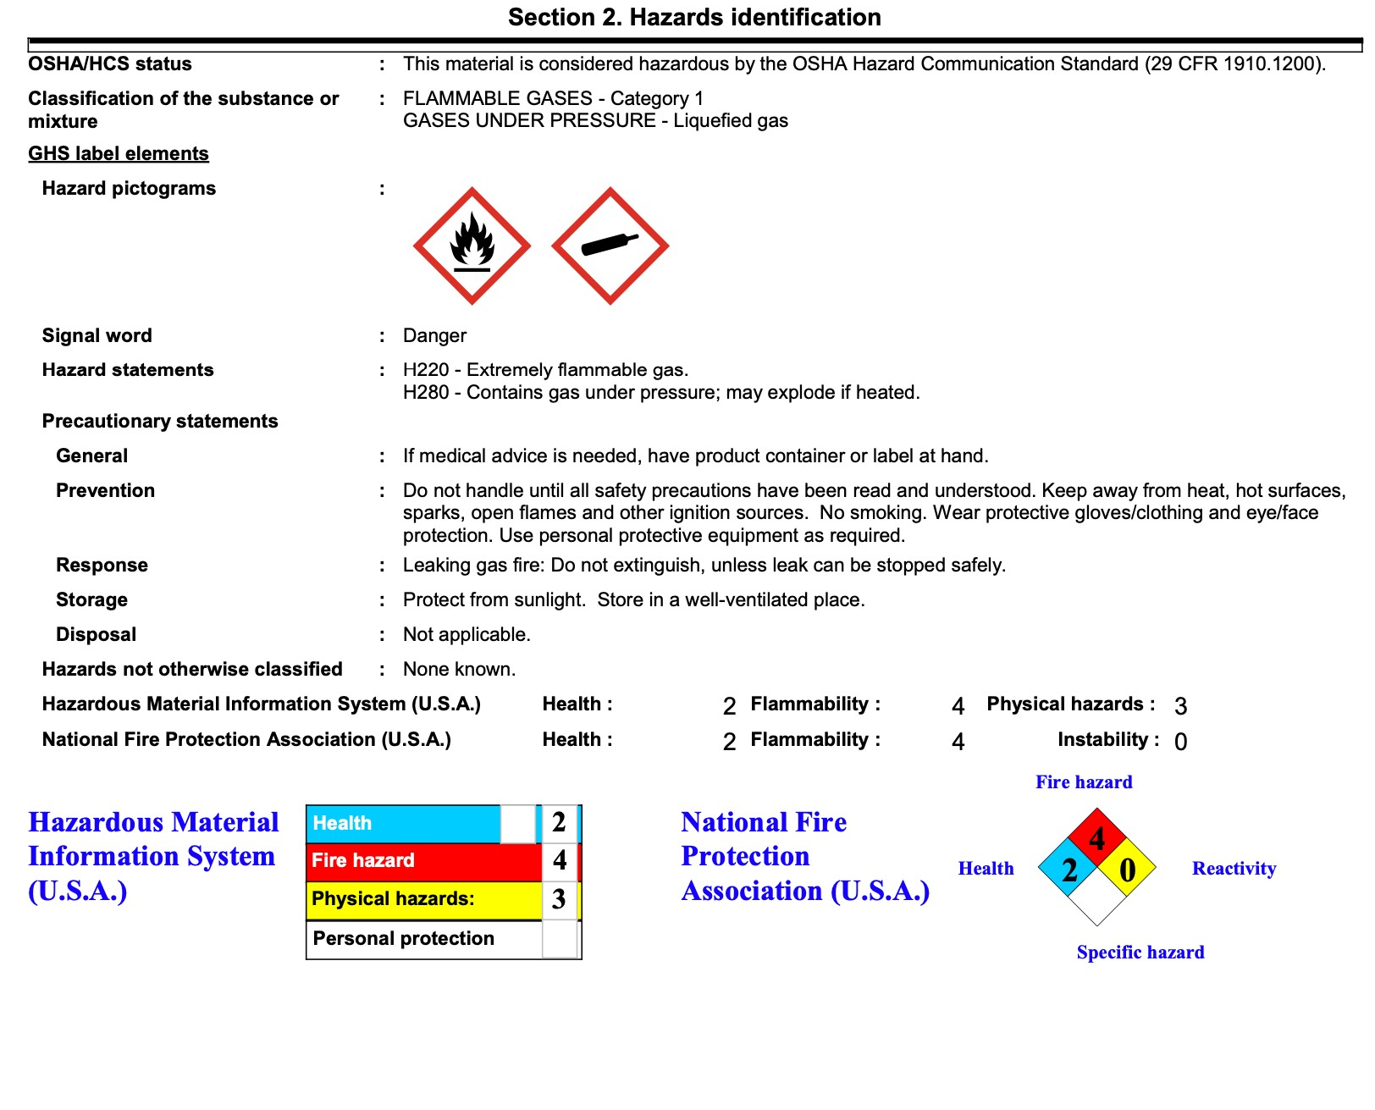

Emergency Contacts
Chris Smart | Balloon Meister/ Event Director | (260) 224-0251
James Mitchell | Assistant Director | (269) 579-0686
Sean Askren | Safety Officer | (513) 594-9070
WDP Dispatch | Emergency/non-emergency | 911 / (330)-334-1511
Terry Grice | Medina County Sheriff | (330)-764-8631
Daniel Chafin | Wadsworth Police Chief | (330)-334-1511
Robert Lindner | Wadsworth Fire Chief | (330)-335-2850
City of Wadsworth | Electrical Department | (330)-335-2833
Nate Santmyer | Propane (on-site) | (330)-466-3615

IMAGE OF BALLOONS OVER WADSWORTH FESTIVAL MAP
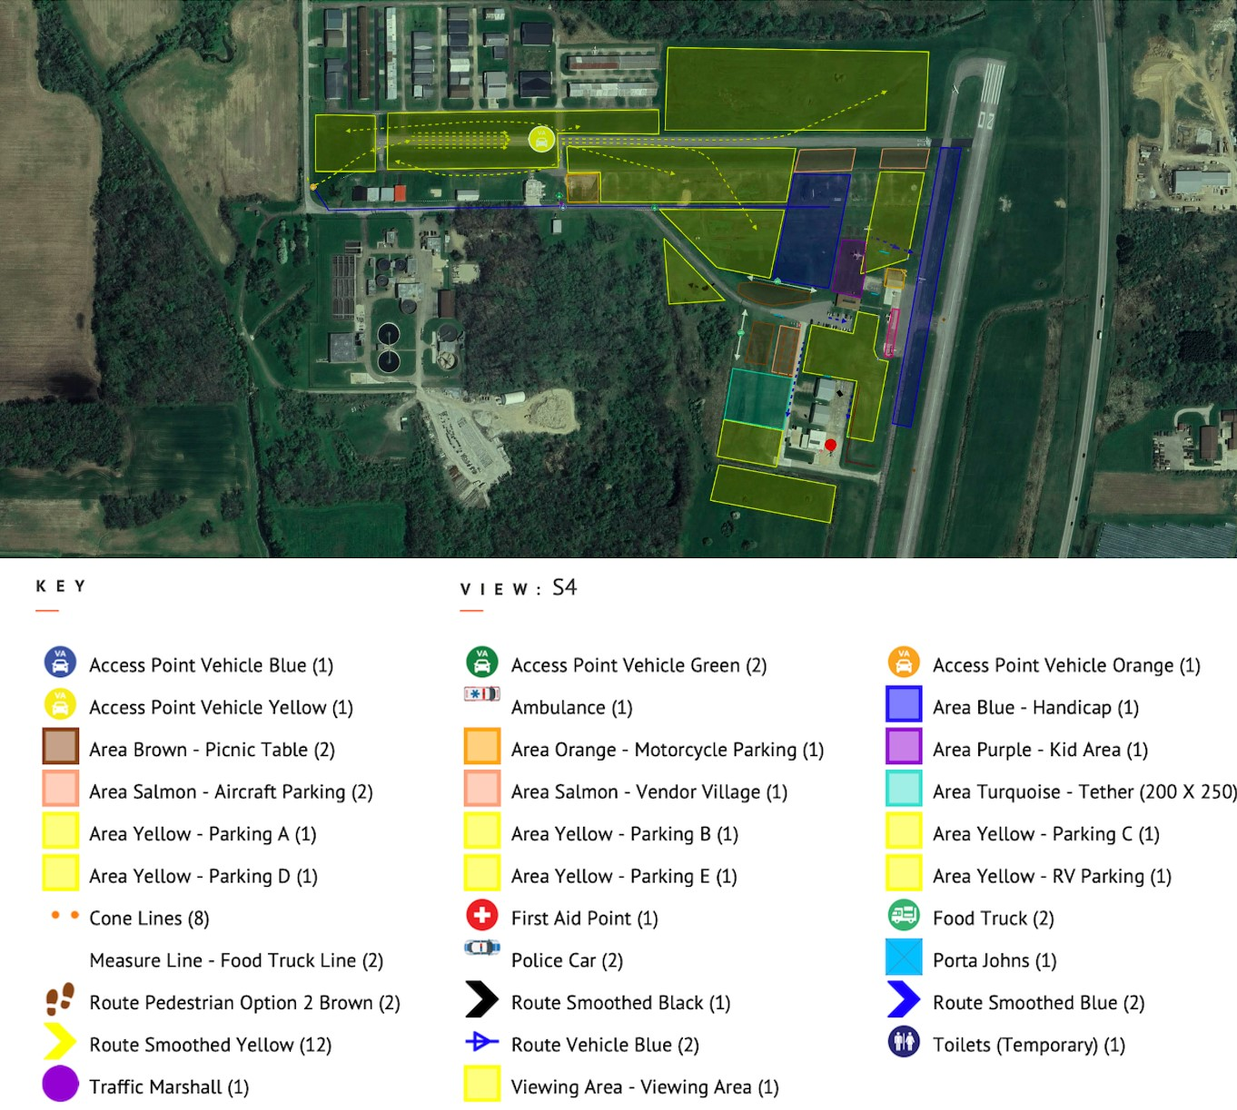

Incident Management Form
Action Log |  | Agency: |  | Date: |  | Page___of___
Event # | Time | Name | Event |  | Action

Security Sign In/Out Log

Balloons Over Wadsworth Incident Command Post
Staff & Visitors: Please sign in & out!!!
Date |  | Time In | Name | Section/Agency | Time Out

Resource Request Status Log (B.O.W.)

Resource  Request # | Resource | Date/Time  of  Request | Date/Time  Forwarded to County | Approved/Disapproval | Date/Time  Notified of  (dis)approval | Comments
 | Balloons Over Wadsworth Pilots 2025
 | First Name | Last Name | Pilot Type | PIC Hrs. | Last 12 Mo | Pass/Wt. | Media Fl | Dist. to WW | Fiesta/Comp
1 | Paul | Dale | Commercial | 284 | 26 | 149 | N | 33 | Comp
2 | Ben | Leatherman | Private | 162 | 50 | 100 | N |  | Comp
3 | Steve | Mitchell | Commercial | 400 | 37 | 150 | Y | 51 | Comp
4 | Sean | Askrin | Commercial | 3100 | 50 | 2 | Y |  | Comp
5 | James | Mitchell | Commercial | 330 | 20 | 600 | Y |  | Fiesta
6 | Meredith | Bennett | Private | 312 | 35 | 125 | N |  | Comp
7 | Darrin | Fall | Private | 180 | 14 | 1 | N |  | Comp
8 | Shannon | Rote | Commercial | 690 | 20 | 200 | Y | 6 | Comp
9 | Jim | Cusic | Commercial | 588 | 30 | 250 | N |  | Comp
10 | Michael | O'Brien | Private | 170 | 20 | 1 lite | Y |  | Comp
11 | Brad | Burdue | Commercial | 1110 | 60 | 400 | N |  | Fiesta
12 | Shawn | Raya | Commercial | 2398 | 38 | 100 | Y |  | Comp
13 | Joey | Strutz | Private | 215 | 40 | 100 | N |  | Comp
14 | Janet | Lutkus | Commercial | 985 | 36 | 150 | Y | 15 | Comp
15 | Travis | Gauthier | Private | 275 | 20 | 400 | N |  | Comp
16 | Garrett | Gerwig | Private | 66 | 25 | 299 | Y | 36 | Fiesta
17 | Larry | Coan | Commercial | 625 | 40 | 150 | N |  | Comp
18 | Chris | Smart | Commercial | 2047 | 65 | 650 | Y |  | Fiesta
19 | Jake | Tyler | Commercial | 500 | 30 | N/A | Y |  | Fiesta
20 | Eric | Eaton | Commercial | 432 | 26 | 0 | Y |  | Fiesta
21 | Rick | Kohut | Commercial | 800 | 28 | 459 | Y |  | Fiesta
22 | Ryan | Duff | Commercial | 200 | 40 | 0 | Y |  | Comp
23 | Eric | Reeder | Private | 211 | 32 | 250 | N |  | Comp
24 | Pat | Karl | Private | 163 | 12 | 300 | N |  | Fiesta
25 | Preston | Lama | RC |  |  |  | Y |  | Fiesta
26 | Jim | Cusic | RC |  |  |  | N |  | Fiesta
27 | Late Entry | Corporate

